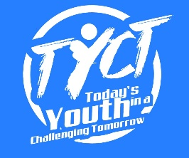
Today’s Youth in a Challenging Tomorrow
138 Brennan Rd
Columbus, GA 31906

Since 2012, Today’s Youth in a Challenging Tomorrow, a 501(c) (3) not profit organization has worked in partnership with the community and family to facilitate events that will empower our youth to be good citizens and make ethical decisions.

On April 13, 2024, Today’s Youth in a Challenging Tomorrow will host an awards banquet at Columbus State University Cunningham Center featuring our community youths. This event, titled Youth Impact Awards, will recognize deserving youth, 8-17 years of age for the remarkable ways in which they have chosen to live. The awards are not academic; rather, they focus on leadership, friendship, overcoming personal challenge and community service. Events like our Impact Awards Banquet builds character and encourage personal achievement.

Honorees, their families and community members will enjoy a fun and festive evening with some fantastic youths, followed by a buffet dinner and awards presentation.

Selection Process
Nominators must fill out a brief Nomination Form with a description of the selected achievement and the nominee’s relevant characteristics.
All nominations are reviewed by our advisory committee and four (4) award recipients are selected to win a grand prize.

Sponsorship
Please consider being one of our official event sponsors. In this role, you and/or your business would provide a generous donation to demonstrate your commitment to social responsibility and community involvement. As a show of gratitude, we would promote your company as the event’s sponsor on all media advertising and print.

Yours sincerely,

Cheryl Gregory
Event Coordinator
cgregory@businesssolutionsofgeorgia.com
706-464-2362

